**Project Design Phase-II**

Technology Architecture

|  |  |
| --- | --- |
| Team ID | PNT2022TMID43975 |
| Project Name | Iot based smart crop protection for agriculture |

**Technical Architecture:**

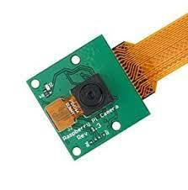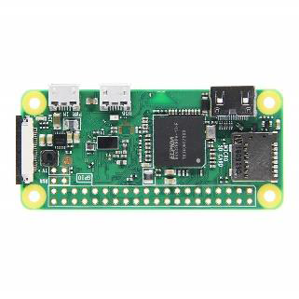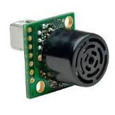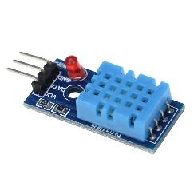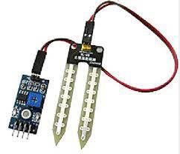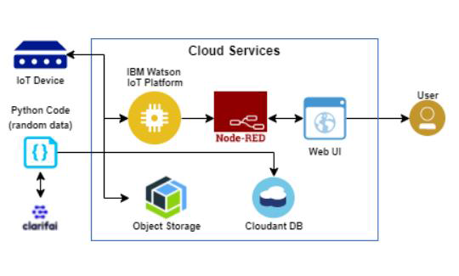

**Table-1: Components & Technologies:**

|  |  |  |  |
| --- | --- | --- | --- |
| **S.No** | **Component** | **Description** | **Technology** |
| **1.** | **User interface** | User interacts through mobile app. | HTML, CSS, JavaScript / Angular Js or MIT App inventor. |
| **2.** | **Application Logic-1** | Used to measure the temperature and humidity level. | Python |
| **3.** | **Application**  **Logic-2** | It is used to build conversational interfaces into any application or device. | IBM Watson Assistant |
| **4.** | **Database** | MongoDB is a source-available cross-platform document oriented database program.it uses a JSON-like documents with optional schemes. | MongoDB |
| **5.** | **Cloud Database** | Cloudant is a non-relational distributed database service which handles software and hardware provisioning, management and scaling and support. | IBM Cloudant |
| **6.** | **File storage** | The collected data’s are stored in the IBM Block Storage. | IBM Block Storage |
| **7.** | **External API-1** | Purpose of this IBM weather API is collect the required data from the cloud. | IBM Weather API etc. |
| **8.** | **Machine Learning Model** | An intelligent system that protects crop from animals by identifying it via camera ant it also measures temperature, soil moisture, humidity level. It also enables the remote monitoring and control of motors. | Object Recognition Model, etc. |
| **9.** | **Infrastructure** | Application development on system / cloud local server configuration. | Local , Cloud Foundry, Kubernetes, etc. |

**Table-2: Application Characteristics:**

|  |  |  |  |
| --- | --- | --- | --- |
| **S.No** | **Characteristics** | **Description** | **Technology** |
| **1.** | Open-source Frameworks | Thingspeak, Ubidot | Wifi / GSM, GPRS |
| **2.** | Security Implementations | Mandatory access control, Discretionary access control, Role-based access control. | e.g. SHA-256, Encryptions, IAM Controls, OWASP etc. |
| **3.** | Scalable Architecture | It refers to a system, network or process that is designed to handle a workload that may change in scope. | Kubernetes, Elastic storage, Load balancer. |
| **4.** | Availability | It is a metric used to measure the percentage time of a machine can be used. | Technology used. |
| **5.** | Performance | Need to simulate devices from different location with required network technologies. | Machine Learning Algorithm. |